Create Service
- Create service
>> ng g s services/countries
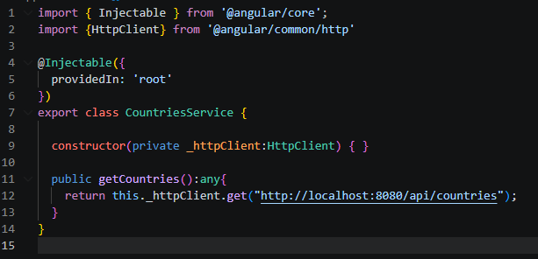

- @Injectable: "This class is a service and can be injected into other classes."
- import {HttpClient} from '@angular/common/http' យក HttpClient មកប្រើប្រាស់សម្រាប់ Rest API (GET, POST, PUT, DELETE)
- constructor(private _httpClient:HttpClient) { } : Constructor + Dependency Injection. ពេលវាចាំផ្តើមដំណើរការ វា បង្កើតមុនគេ (Constructor runs when Angular creates the service.)
- private _httpClient: This creates a private variable.
- public getCountries(): any {} = This creates a function កន្លែងដែលយើងដាក់ API
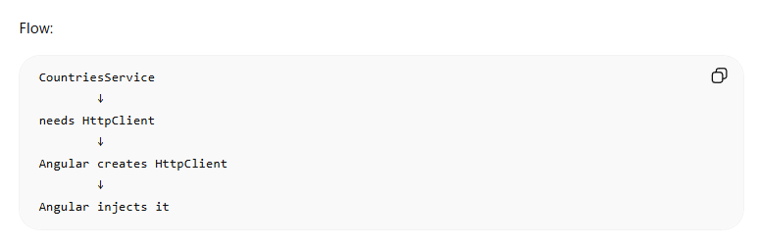

- Create component
>> ng g c components/countries
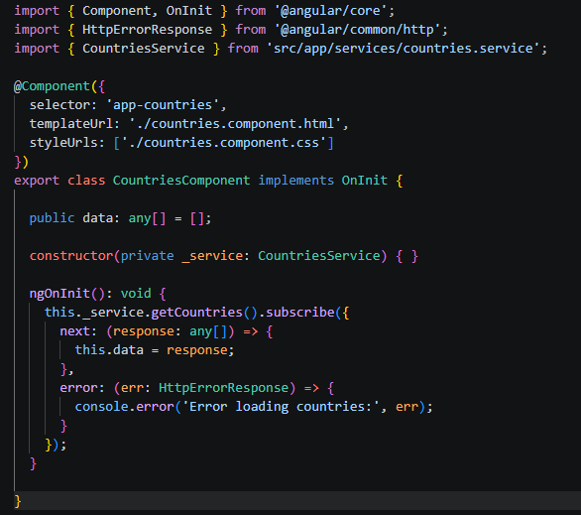

- OnInit: Run code when component starts.
- import { HttpErrorResponse } from '@angular/common/http' : Used for API error handling.
- constructor(private _service: CountriesService) { }: Inject the service
- public data: any[] = []; បង្កើត variable
- HTML
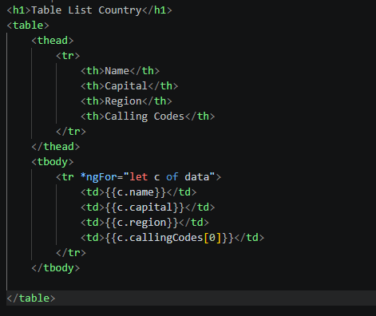

- View it: app.module.ts
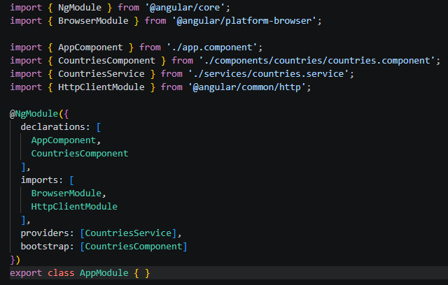

- providers: [CountriesService] យើងដាក់ Service ចូលក្នុង providers
- bootstrap: [CountriesComponent]: កន្លែងដែល កម្មវិធីចាប់ផ្តើម starter app ចឹងបើយើងដាក់ component អីវានឹងបង្ហាញអានឹង
- Index.html
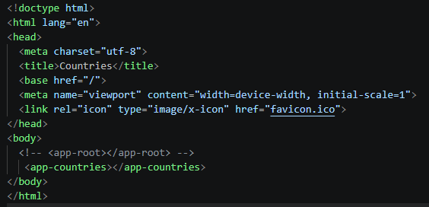

- <app-countries></app-countries> inside the body we put the component where we want to display

